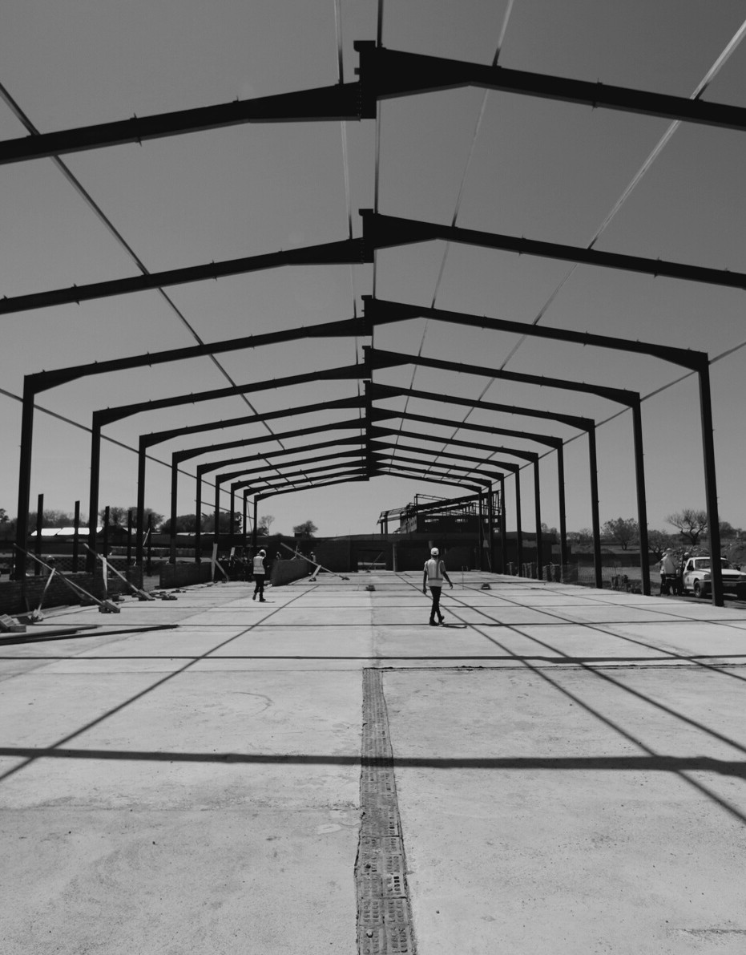
NALE
HOLDINGS

Brochure 2022



- ABOUT NALE HOLDINGS 1
CONTENTS
Client Focus
- OUR STATEMENTS OF ETHICAL 2
PRINCIPALS
Vision Statement Mission Statement Accountability
- OUR MISSION 3
- PERSONNEL 4
Resources Technology Requirements

- OUR SERVICES Pre-Contract Services Post-Contract Services Detailed Services
TABLE
OF
5-6

- COMPLETED PROJECTS 7
- CURRENT PROJECTS 8
- OUR BUSINESS 9
XI. OUR PORTFOLIO 10-13
X. CONTACT INFORMATION 14

NALE HOLDINGS

Brochure 2023

ABOUT NALE HOLDINGS (PTY) LTD

CLIENT FOCUS
Our practice consolidates the quantity surveying, civil engineering, project & facilities management, property management & development and asset management experience gained over a period of thirty (30) years. The knowledge of the client’s needs is of prime importance to ensure that service required is service the client receives.

Nale Holdings (Pty) Ltd is a Professional Quantity

Surveying Practice, registered with the Association of South African Quantity Surveyors, providing quantity surveying, civil engineering, interior design/space planning, cost consulting, facilities management, and project & construction management services and we are based in Pretoria, South Africa.

Nale Holdings (Pty) Ltd was established in July 2012 by Mmote January Nale (Director). The company is 100% HDI-owned and brings in-depth knowledge of Quantity Surveying, Cost Consultancy, Facilities Management,
Project & Construction Management and a broad range of skills through professional business of Quantity
Surveying gained from more than 30years’ experience in the private sector.

PAGE 1

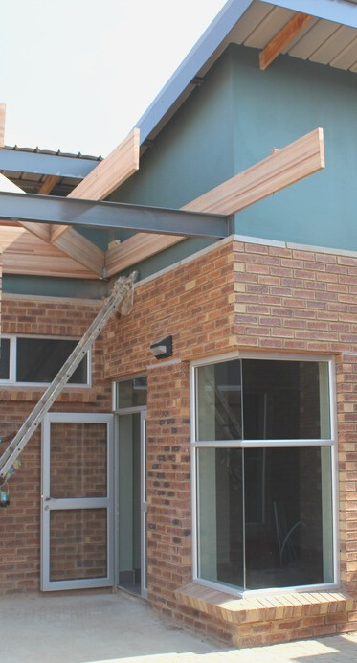

ACCOUNTABILITY

Provide information and warning of matters within our knowledge which are of potential detriment
to others who may be
adversely affected; such warning being given in
sufficient time to allow the taking of effective action.

VISION STATEMENT

Quantity Surveying, Facilities and Project Management are an organization where
continuous and measurable improvement in service is the standard. We will be
recognized by the community as the service provider of choice.

We will do this; by delivering excellent
service, by being a partner in addressing our clients'
needs, by fulfilling our stewardship role, and by being an innovative leader in quantity surveying, facilities
and project management.



MISSION STATEMENT
To provide an independent, objective, accurate and reliable capital outlay, maintenance and operating costs assessment usable for investment funding and project control decisions.

PAGE 2

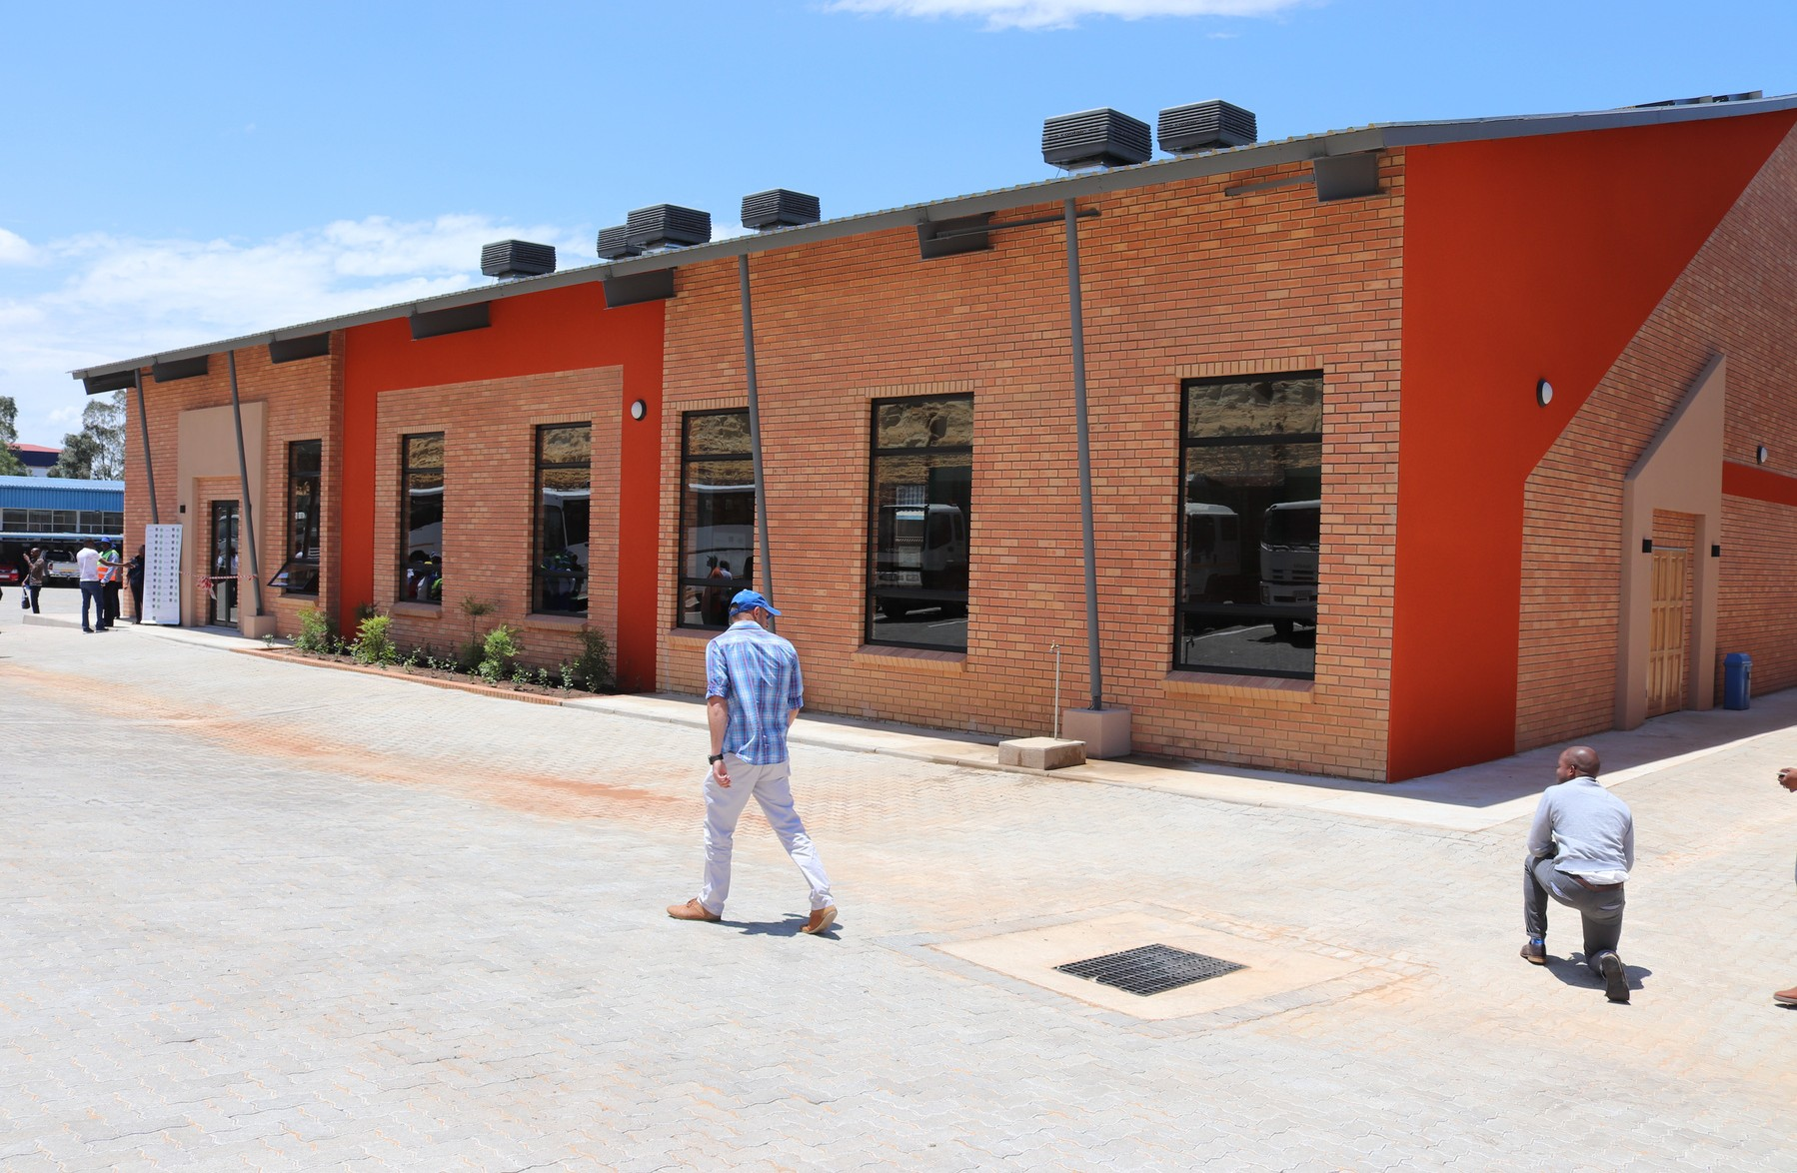
''Nale Holdings approach is flexible, friendly and dedicated to producing successful outcomes in terms of quality, cost and time''

Through investment in people, processes and technology our mission is to provide the most effective, high-quality service to every client. Whether it's traditionally based individual development or a complex, multi million rand Government procurement contract delivered by a consortium of providers, we apply the same rigorous approach from start to finish.
Trust: Our people have skills and knowledge to handle any project.

Value: We focus on continuous improvement to save time and money.
Certainty: We have resources to ensure that we always deliver.

PAGE 3

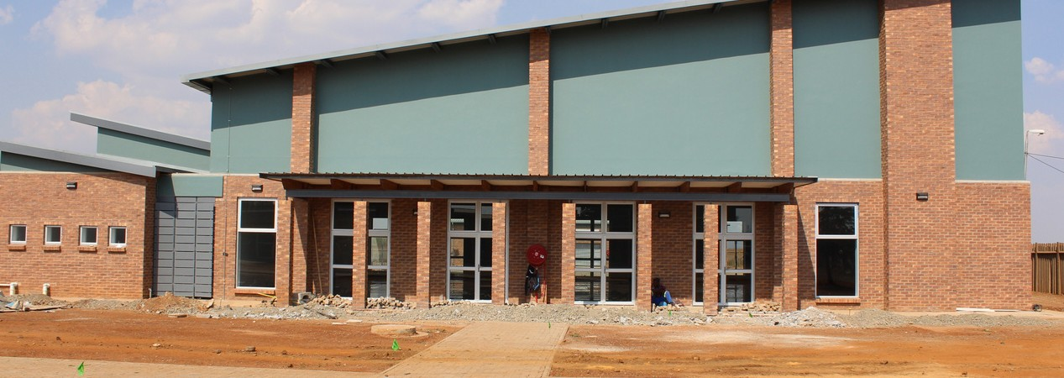
PERSONNEL
The director is personally involved in all
aspects of the services provided and utilizes
other professionals or technical resources with complementary skills which may be contracted in from a network of competent people and
from the association or affiliation with other companies.

Our staff is selected and trained where necessary to meet and fulfill the client's requirements.

RESOURCES TECHNOLOGY REQUIREMENT
Our offices are fully computerized and we
make use of WinQS, CAD, Microsoft Projects and Self- Developed Systems are utilized within this technology.
Other project control systems are used in conjunction with the client’s particular requirements where applicable.

.

PAGE 4

PAGE 5
The firm offers the following services:

Quantity Surveying
Building Cost Consultants
Facilities Management
Turnkey Solutions
Project Management
Construction Management
Architecture
Interior Design
Engineering Services

PAGE 6

Pre-Contract Services

Preparation of feasibility studies and analysis of various design consideration Preparation of cost estimates and base cost planning from sketch designs
Detailed design monitoring in relation to the accepted schematic and cost plan to set an allowable expenditure budget
Contract documentation involving drawing up of conditions of contract, tendering schedules for calling upon various tenderers, adjudication of tenders and assistance with the appointment of service providers/contractors and sub-contractors

Post-Contract Services

Progressive cost control and monitoring design developments during the construction phase including measuring, calling upon tenders for variations and continual costing and reporting on variations, budget levels and drawing up of cash flows.

Detailed Services Includes:

Financial control of projects from inception to completion Financial reporting regarding authorized and contract values
Analysis of Financial effects of changes and variations on the authorized budget Design and construction variation cost control and reporting
As-built site measurements Final account settlements Contract claim negotiations Detailed life cycle costing

Contract Advice

Minimization of the risk of contractual claims through the selection of the most suitable procurement system for the envisaged work
The clients’ objectives are analysed to provide the most cost-effective and risk-free procurement route to follow when considering terms of scope, cost, time and quality

Financial Audits

Projects also often extend their pre-defined contractual and budget limits, invariably where cost control procedures are inadequate.
Financial audit provides a report on the contractual efficiencies, contractors' and consultants' performances, as well as their accountability and professional integrity.

Claims Advice

Disputes often arise from the interpretation of contractual documents and related events.
We provide a financial analysis of claim issues, including the preparation of expert opinion of contractual claims.

Life Cycle Costing

Life cycle costing aims to identify the most cost-efficient design option when considered over the functional life of the capital asset.

Risk Management

Risk Management techniques consider all the potential adverse conditions, which may affect the construction process.
Planned avoidance or transfer of risk ensure that the developers’ anticipated return is achieved

Facilities Management

Assets data collection with a focus on refurbishment, archiving existing building elements, materials and redecoration schedules.
Planned and preventative maintenance schedules

ENGINEERING SERVICES

Provides a wide range of services to the engineering industry. The firm has earned a reputation for providing quality work combined with an innovative approach to the client’s particular needs. Services may be provided individually or as an integrated package.

PAGE 7
PAGE 8



PAGE 9
Our BUSINESS

''We have been involved in various projects namely shopping centers, office buildings, residential developments, warehouses, golf course developments, etc.

Our involvement with government projects includes schools, clinics, hospitals, police stations, colleges of education, recreational facilities such as game reserves, sports centers, etc.''

-MMOTE NALE
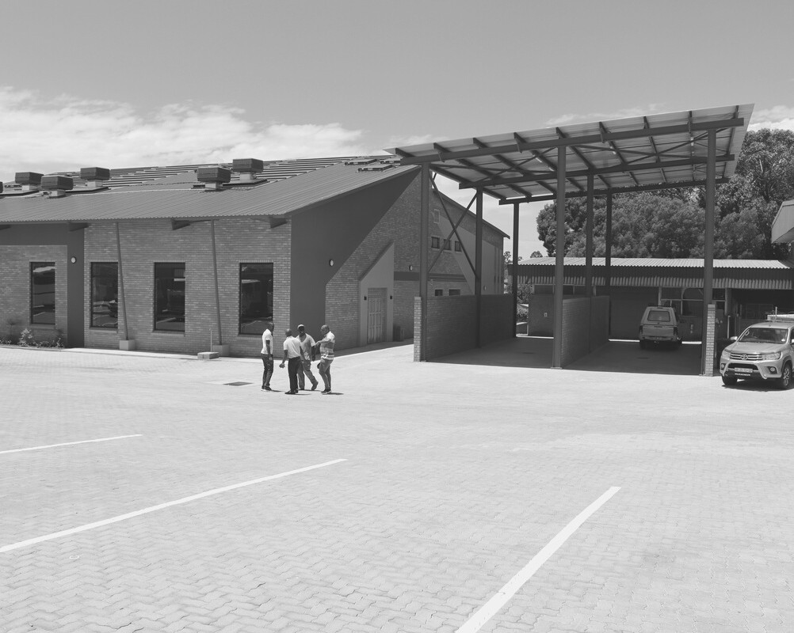
(DIRECTOR)
SERVICE QUALITY
"We deliver consistently high-
quality services on time and to budget.
We are well known for our flexible, "can-do" ethos and attention to detail on all our projects."

PAGE 10

Boksburg Depot
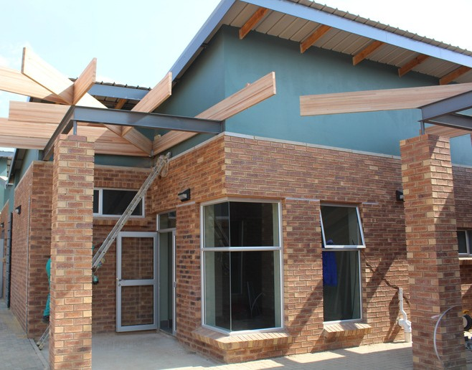
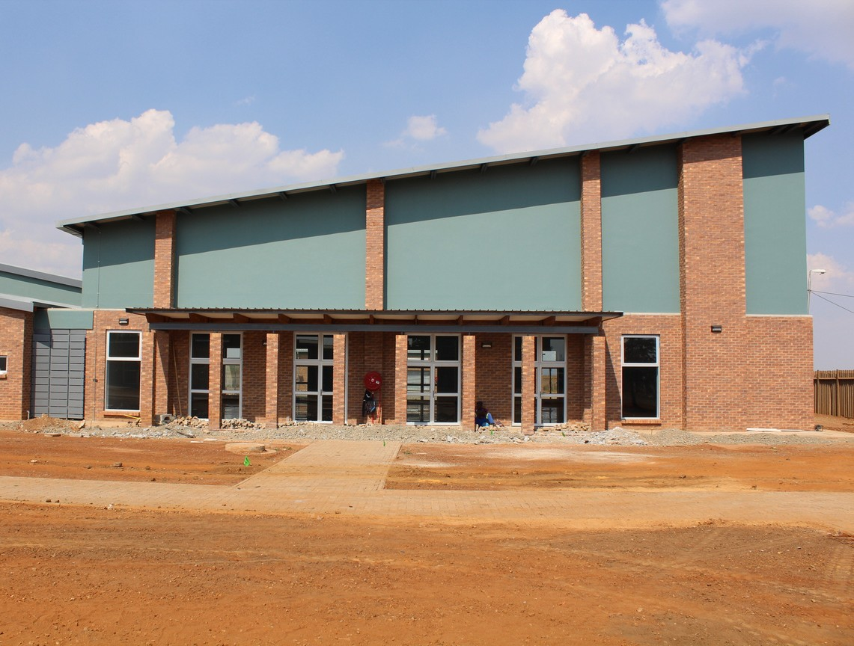
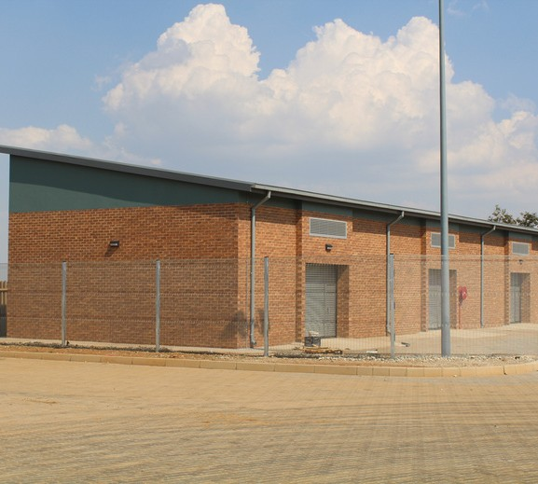
Southdale Depot
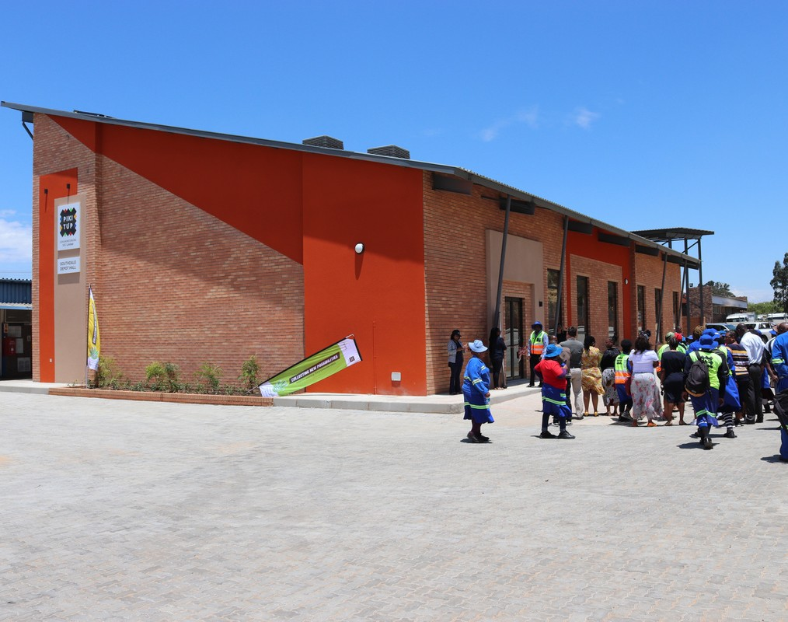
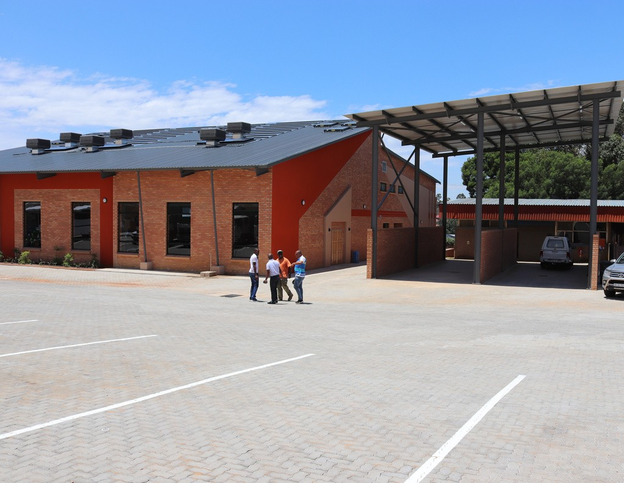
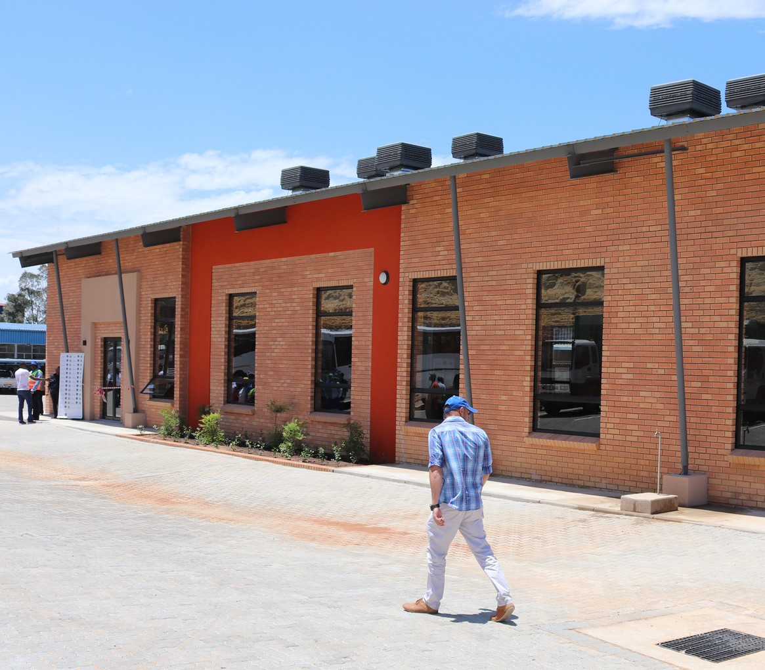
Ramasedi Community Hall
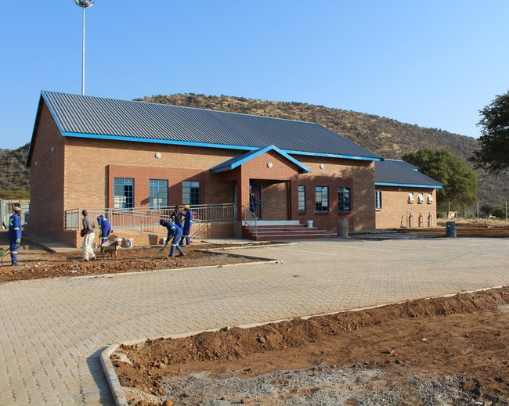
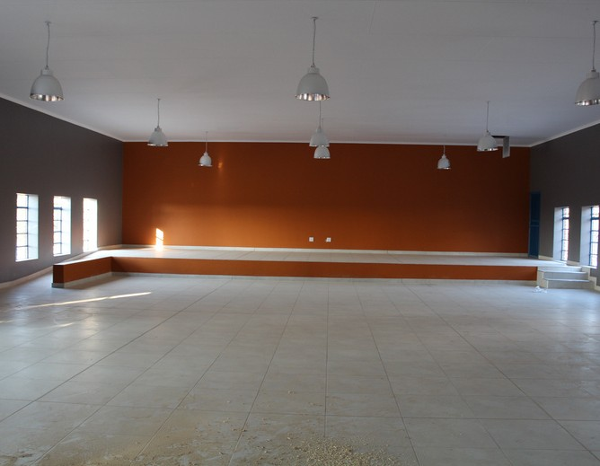
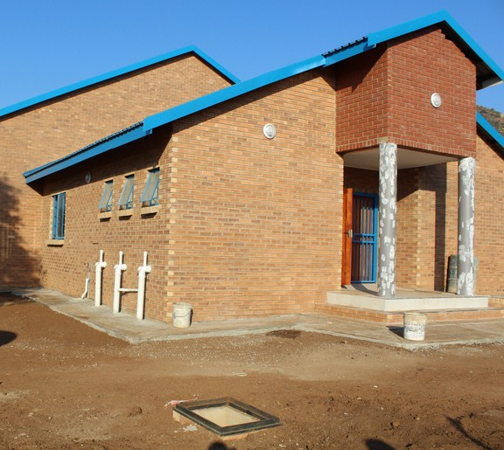

PAGE 11

Toekomsrus Sports Complex
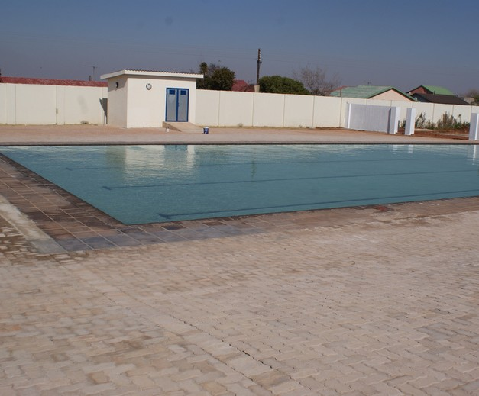
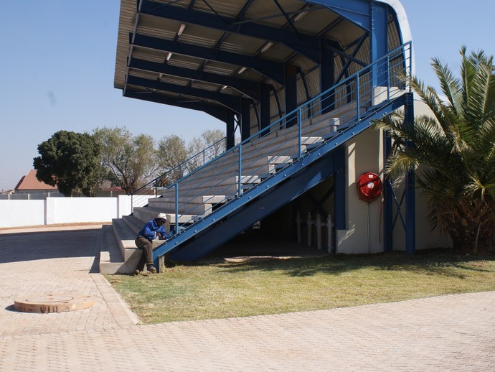
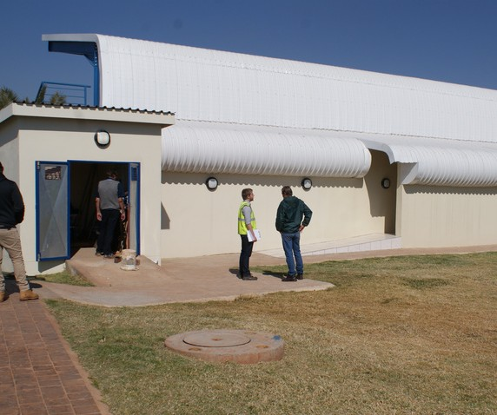
Vuwani: 15 SAI BN MESS
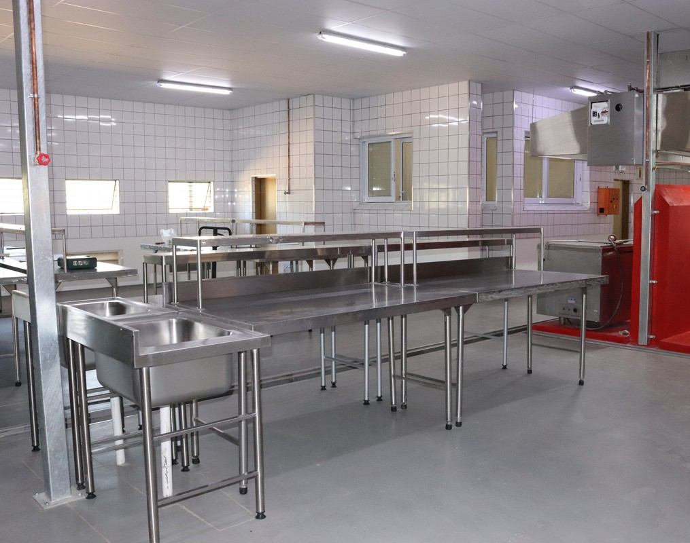
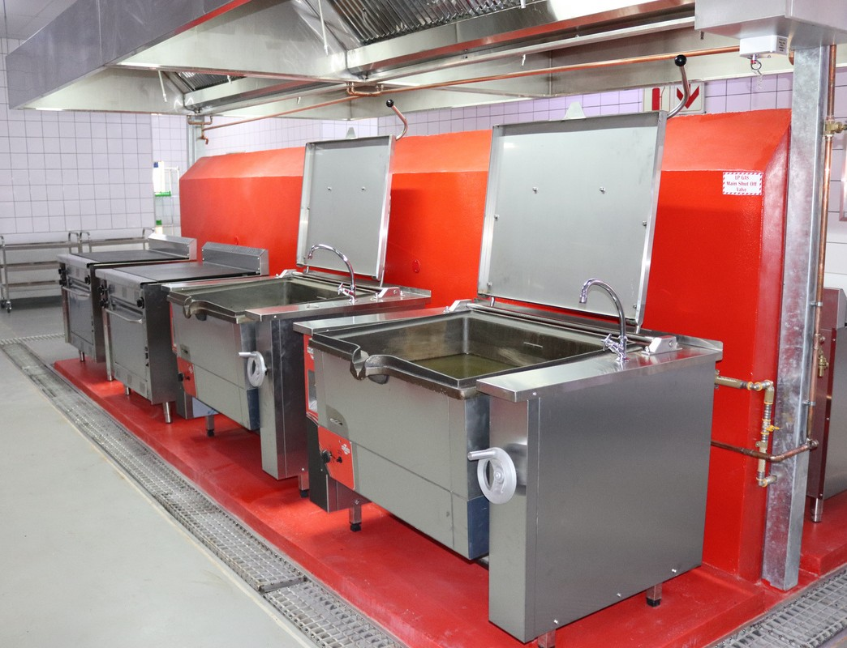
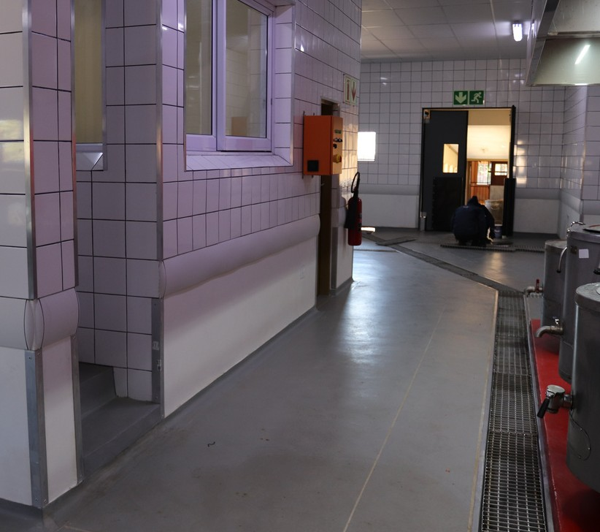
Tselaathuto Secondary School
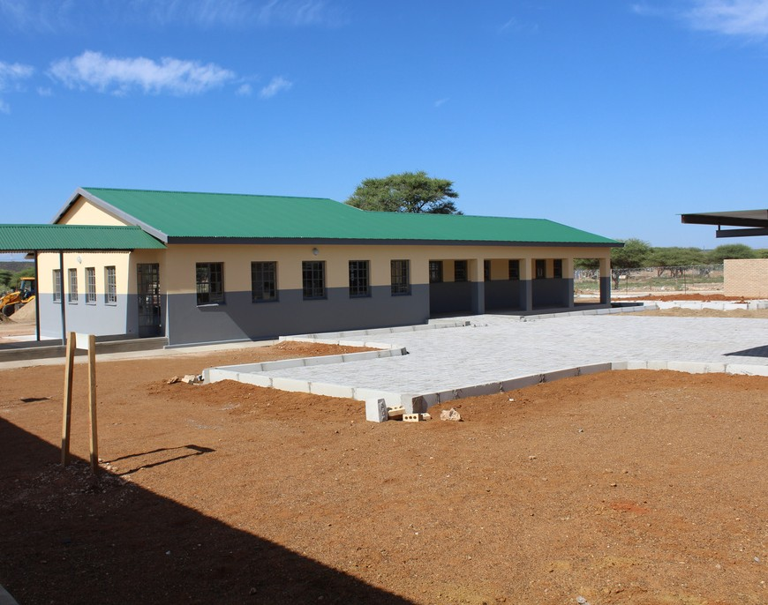
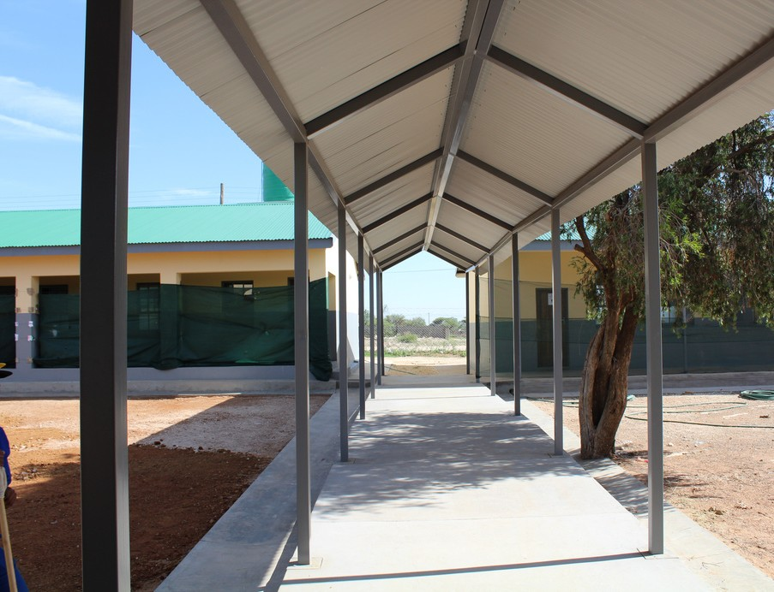
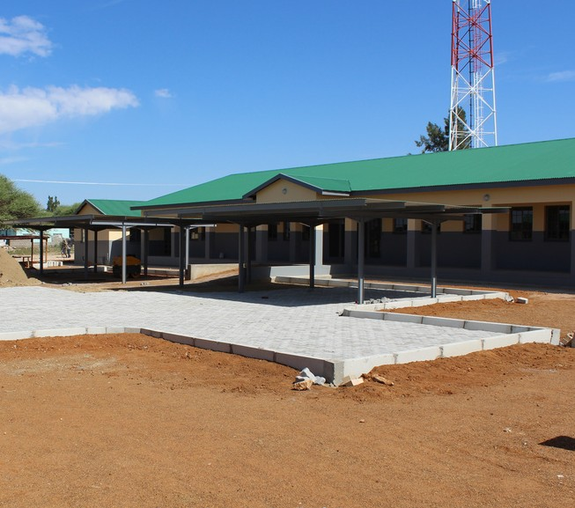

PAGE 12

Kebinelang Secondary School
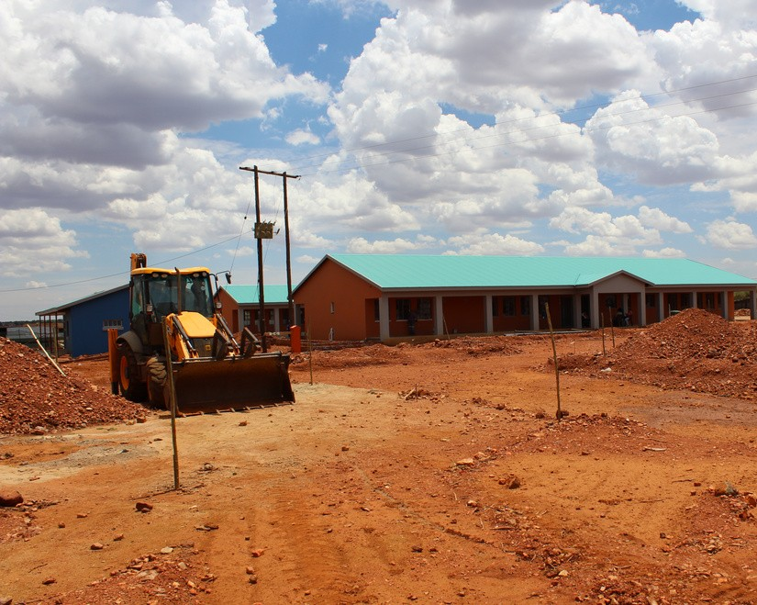
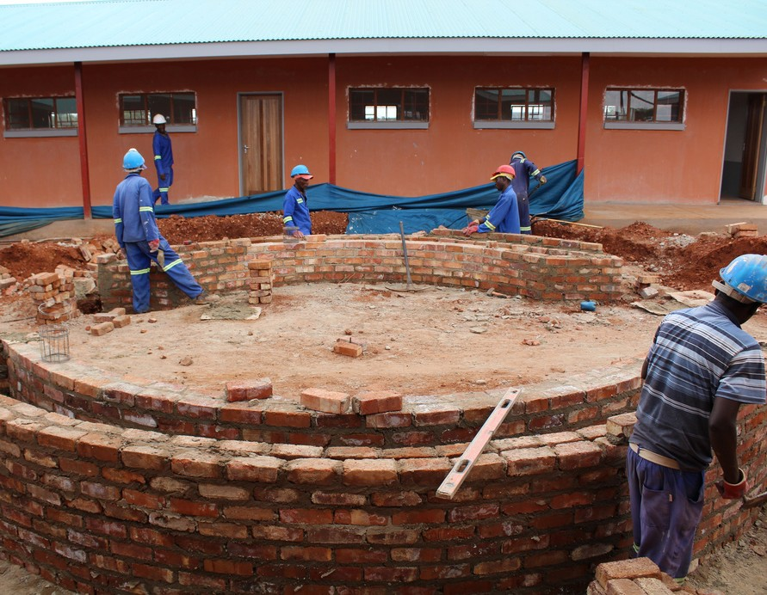
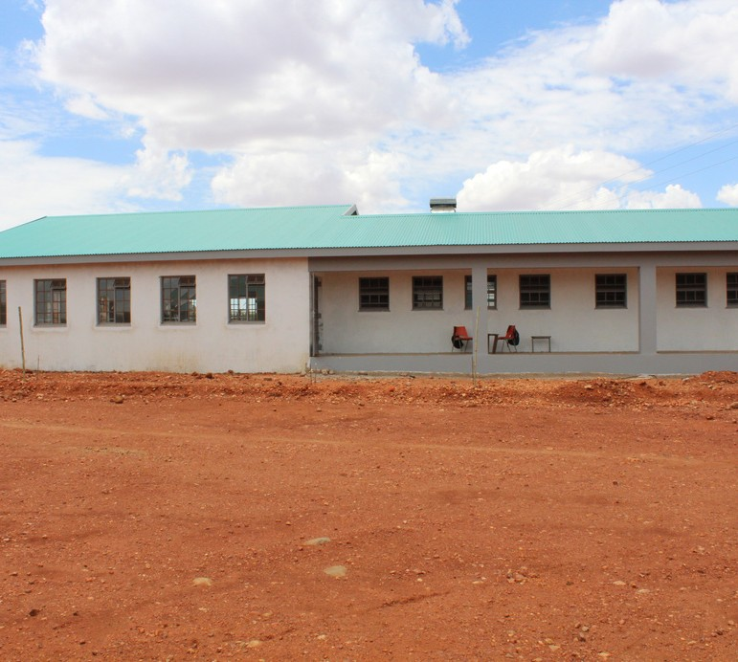
Hikane Primary School
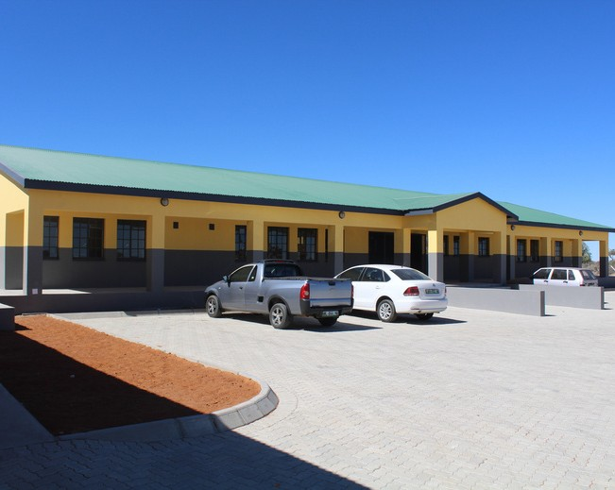
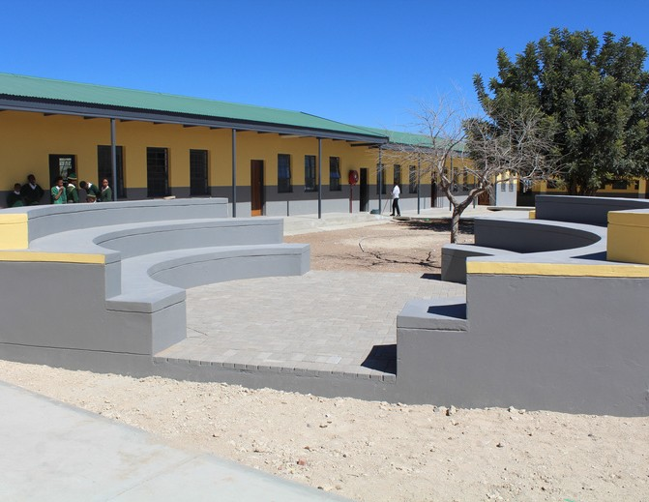
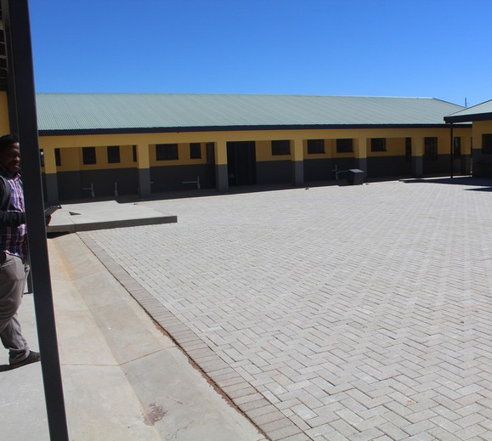
Maseven Clinic
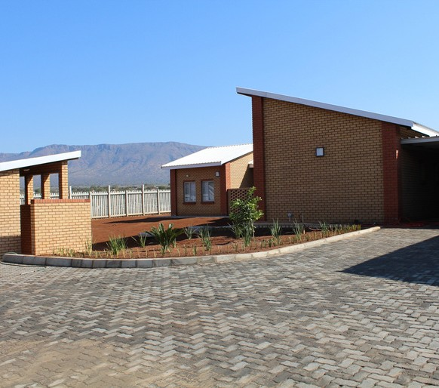
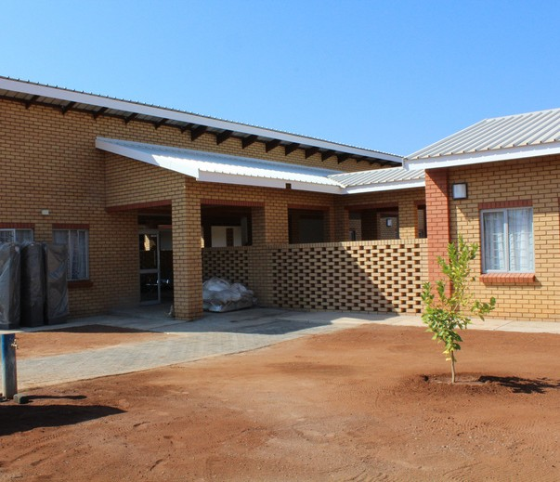
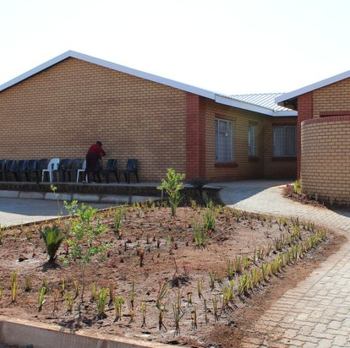

PAGE 13

Mamodimakwana Primary School
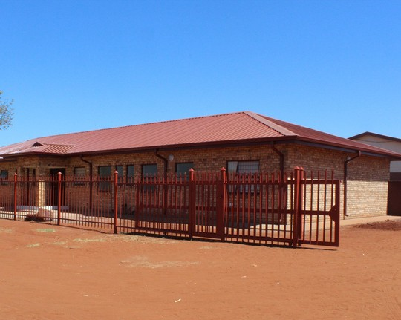
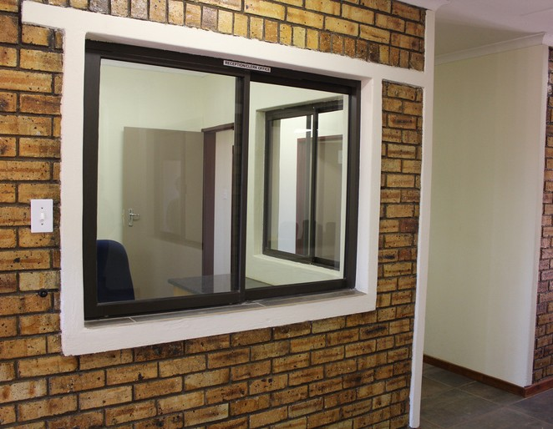
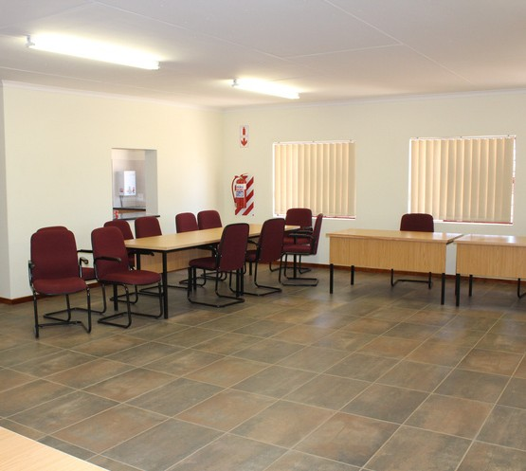
Sekhukhune TVET College
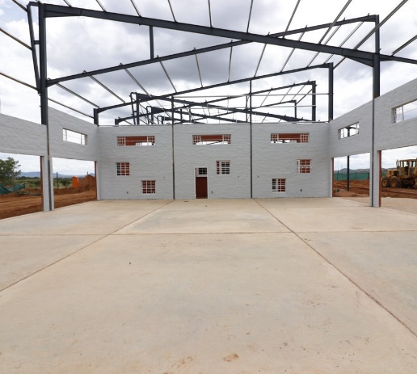
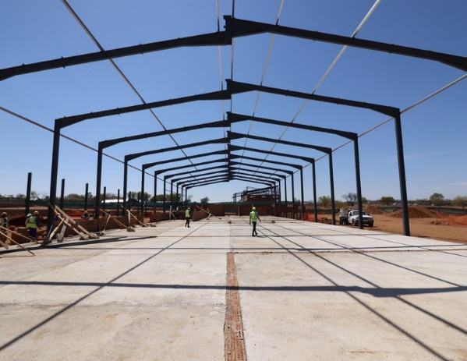
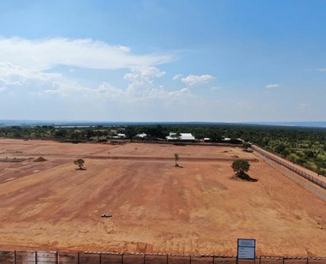

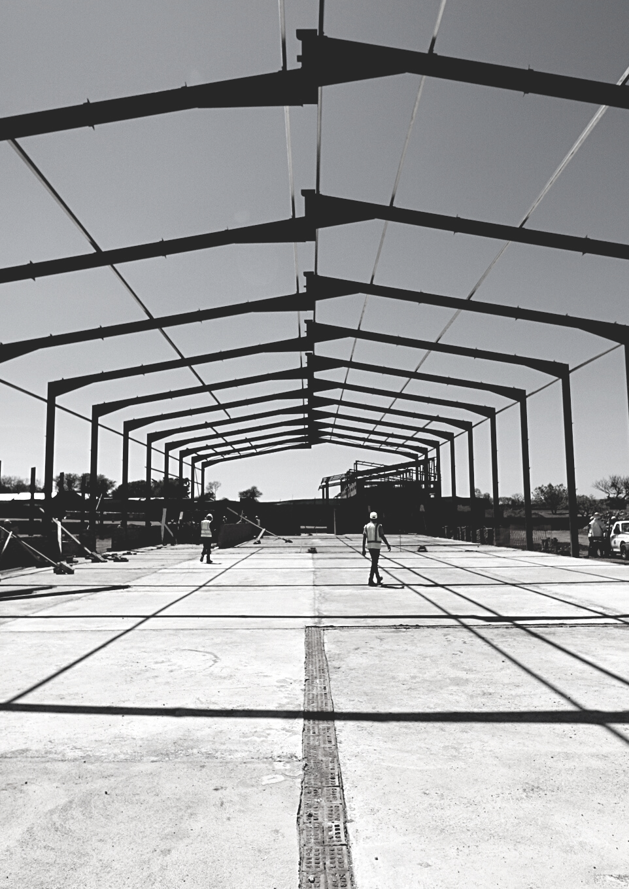





Address
Gauteng Province

Nale Holdings (Pty)Ltd
244 Jean Avenue, Norma Jean Square, Unit No.17, Die Hoewes, Centurion, 0157

Contact details

Tel : | (012) 640 4046
Fax: | 086 533 1844
E-mail: admin@naleholdings.co.za

facebook.com/naleholdings

twitter.com/naleholdings @nale_holdings

PAGE 14

